**ASSIGNMENT 5 ( TICKET BOOKING SYSTEM)**

1)Create a database named “TicketBookingSystem”

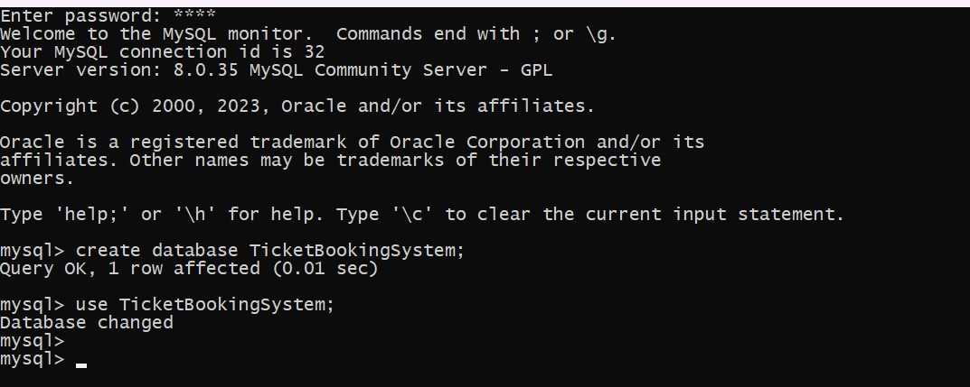

2) Write SQL scripts to create the mentioned tables with appropriate data types, constraints, and relationships.

• Venu

• Event

• Customers

• Booking

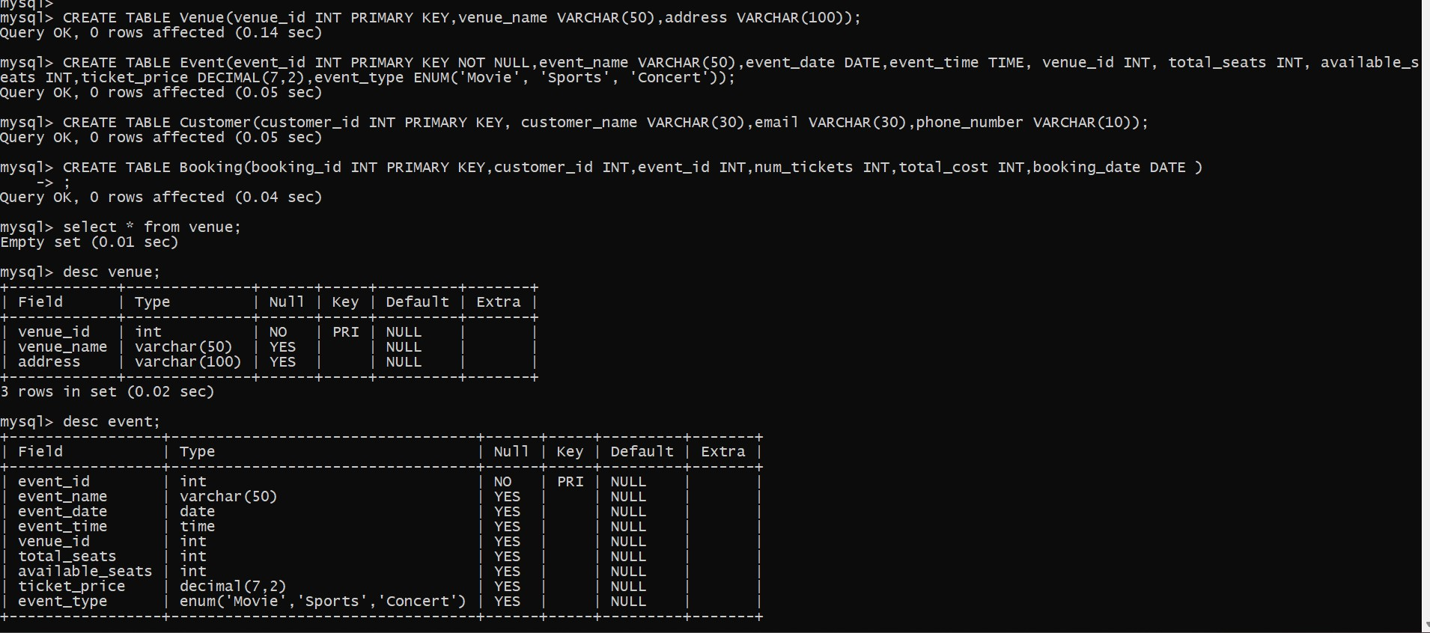

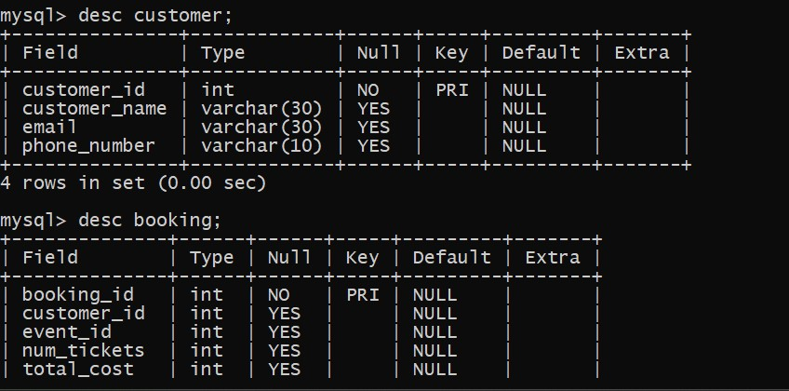

3) Create appropriate Primary Key and Foreign Key constraints for referential integrity.

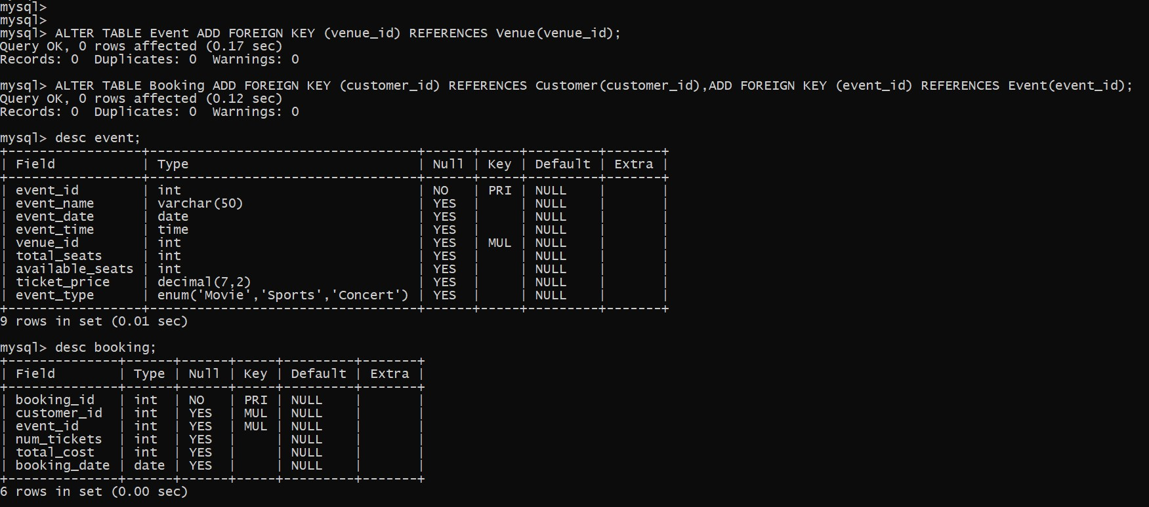

Data Manipulation Language (DML)

1. Write a SQL query to insert at least 10 sample records into each table.

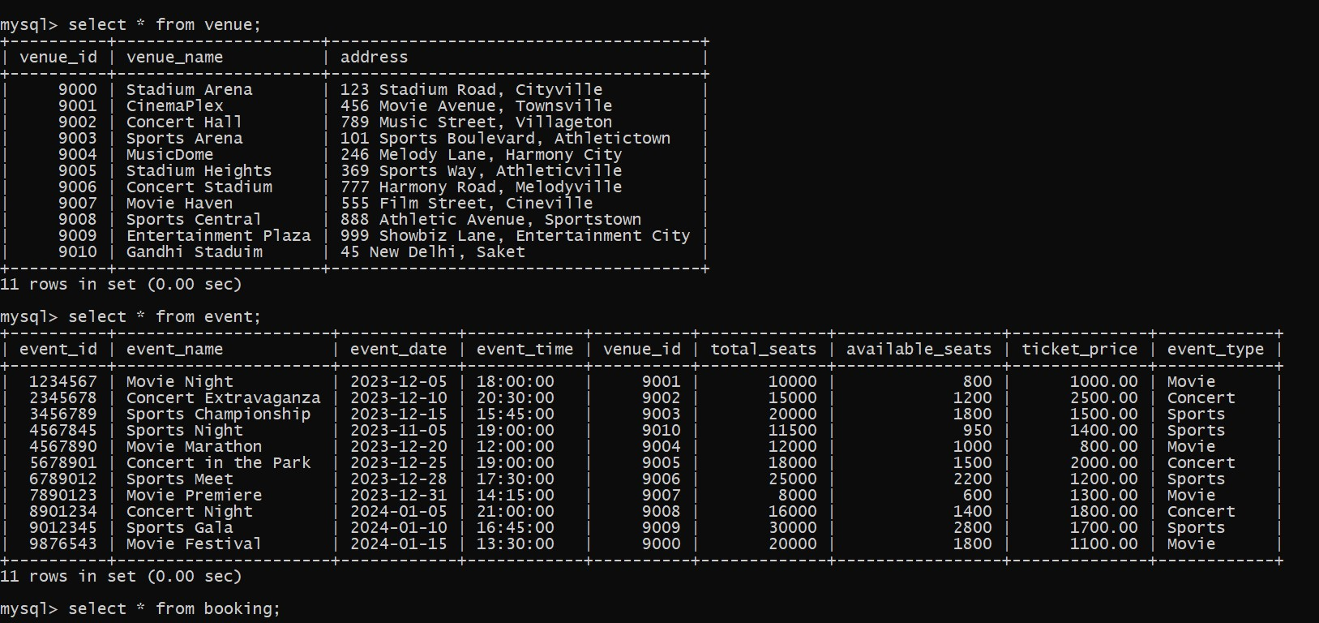

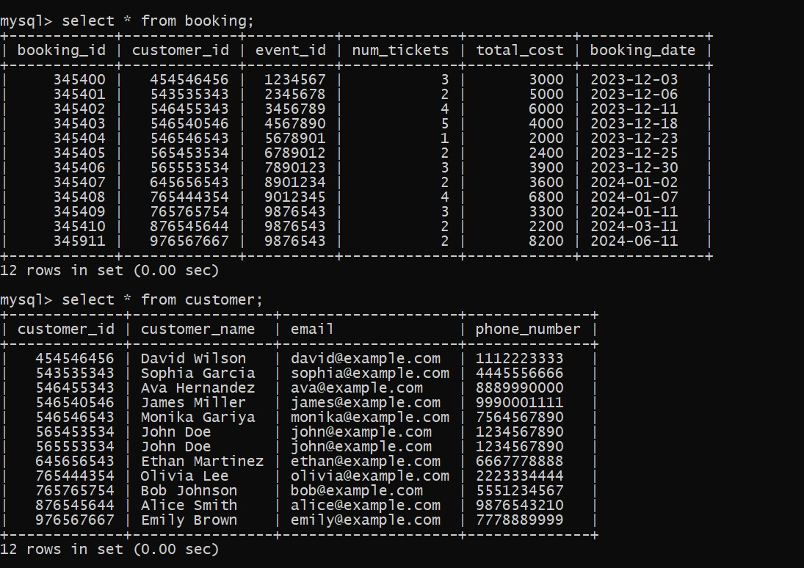

1. Write a SQL query to list all Events.

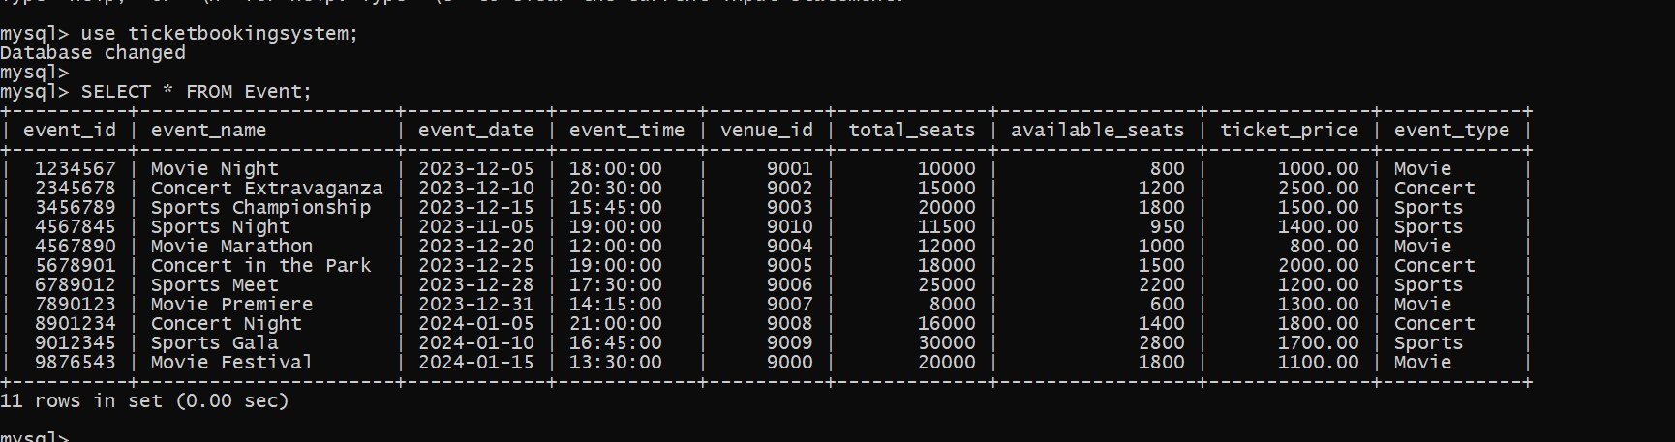

1. Write a SQL query to select events with available tickets.

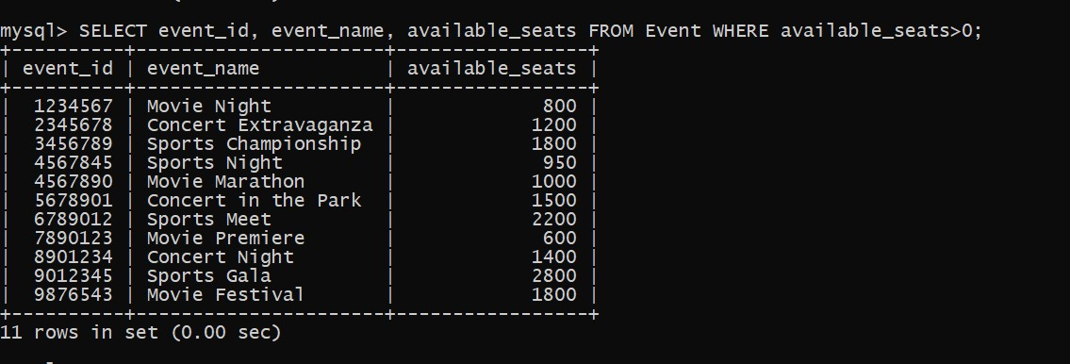

1. Write a SQL query to select events name partial match with ‘cup’.

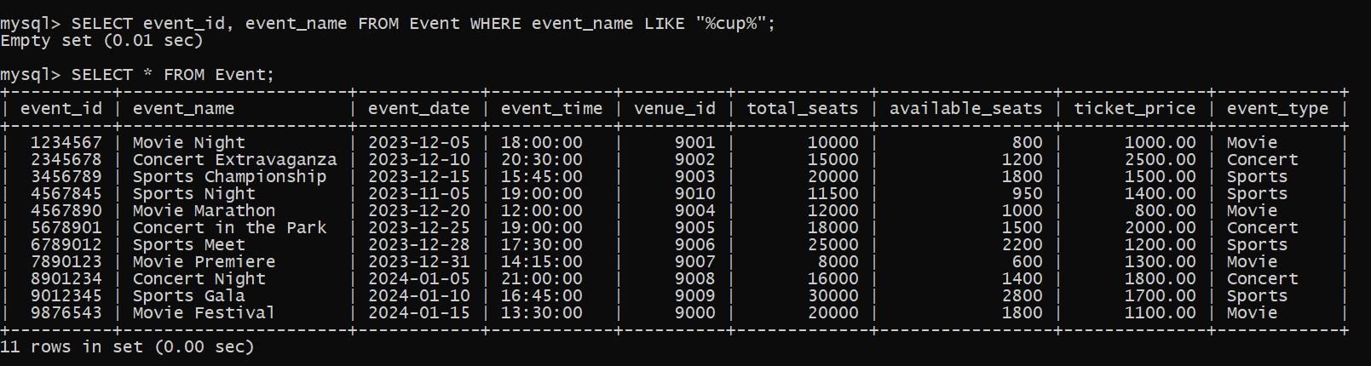

5.Write a SQL query to select events with ticket price range is between 1000 to 2500.

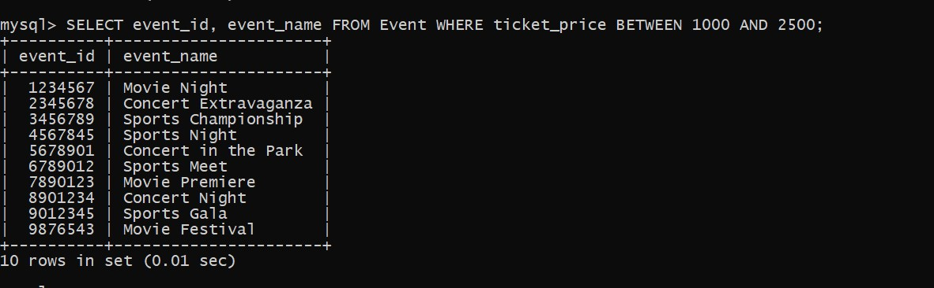

6.Write a SQL query to retrieve events with dates falling within a specific range.

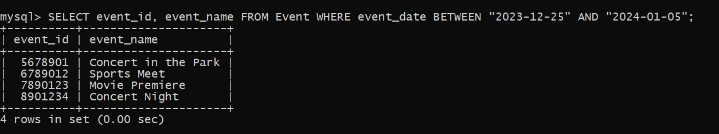

7. Write a SQL query to retrieve events with available tickets that also have "Concert" in their name.

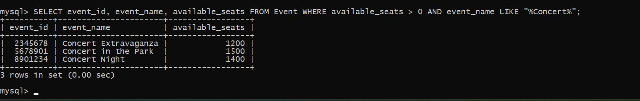

8. Write a SQL query to retrieve users in batches of 5, starting from the 6th user.

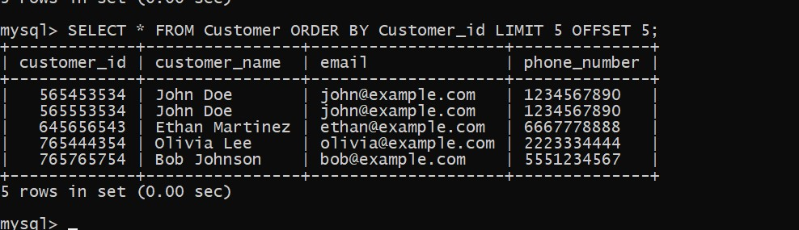

9.Write a SQL query to retrieve bookings details contains booked no of ticket more than 4.

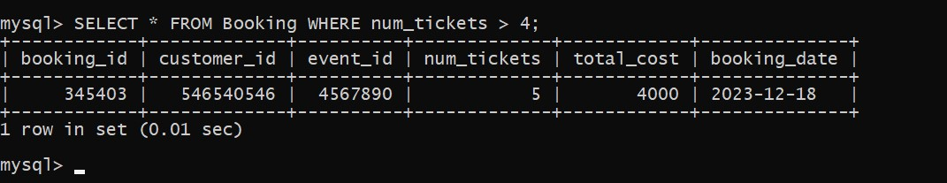

10. Write a SQL query to retrieve bookings details contains booked no of ticket more than 4.

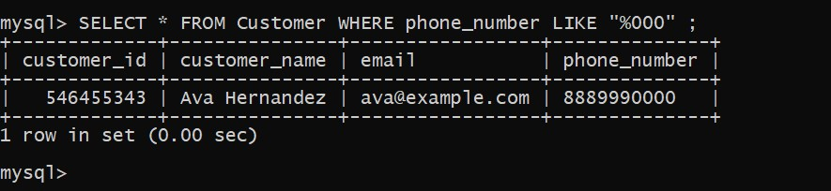

11. Write a SQL query to retrieve the events in order whose seat capacity more than 15000.

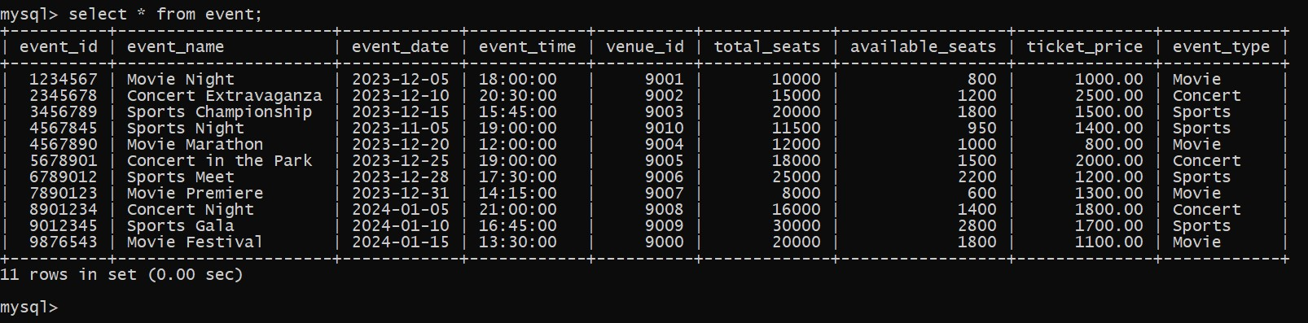

12. Write a SQL query to select events name not start with ‘x’, ‘y’, ‘z’

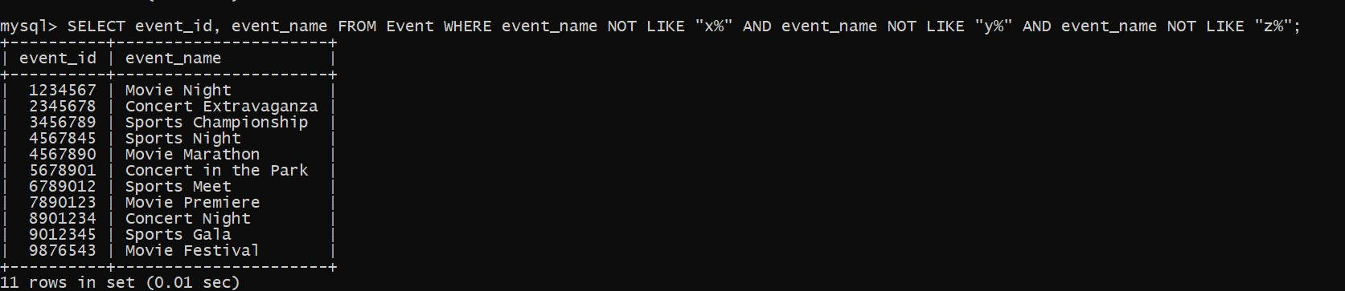

**Aggregate functions, GroupBy and Joins**

1.Write a SQL query to List Events and Their Average Ticket Prices

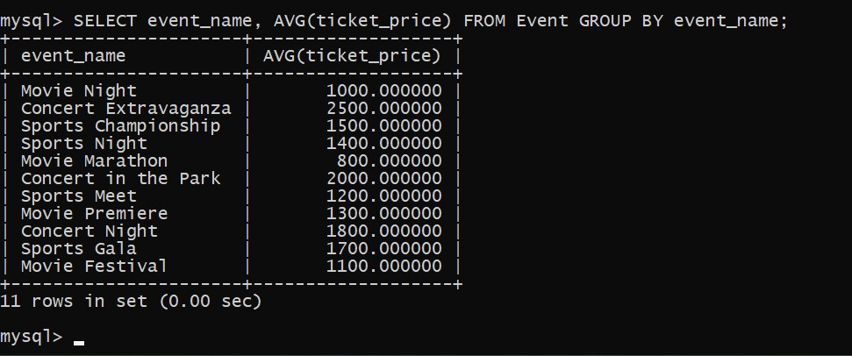

2. Write a SQL query to Calculate the Total Revenue Generated by Events.

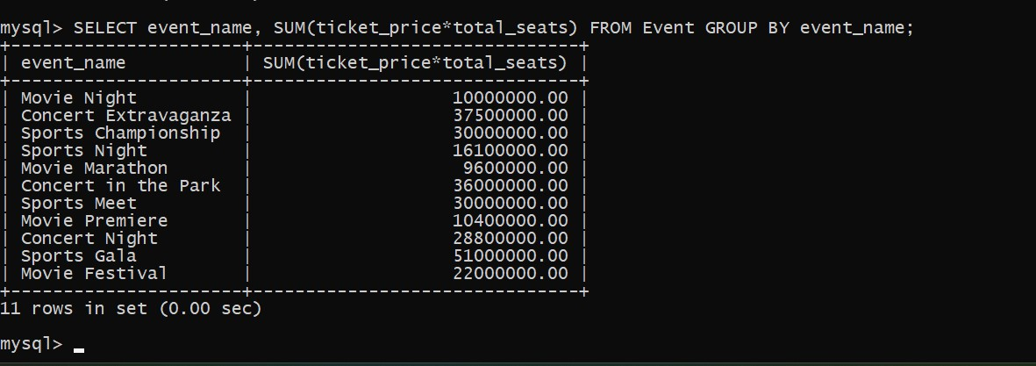

3. Write a SQL query to find the event with the highest ticket sales.

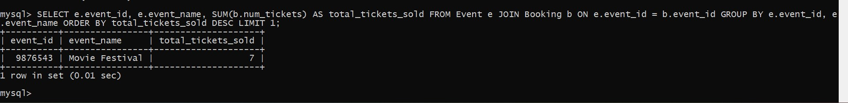

4.Write a SQL query to Calculate the Total Number of Tickets Sold for Each Event

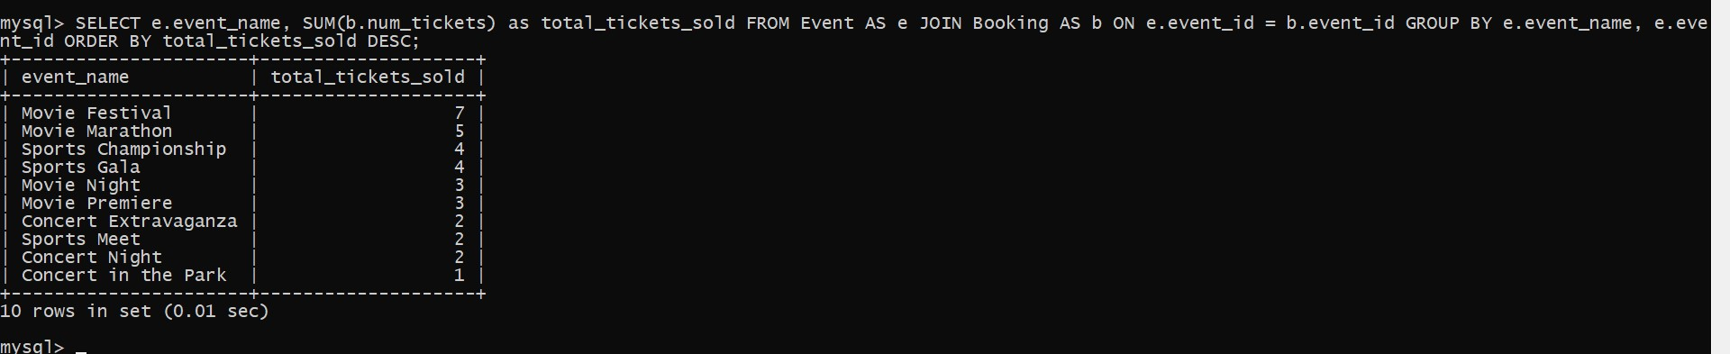

1. Write a SQL query to Find Events with No Ticket Sales.

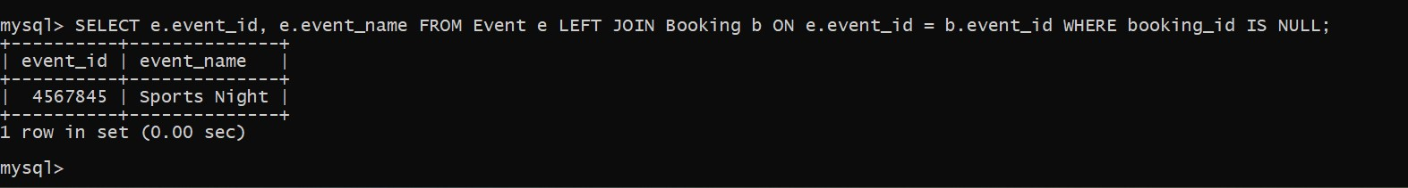

1. Write a SQL query to Find the User Who Has Booked the Most Tickets.

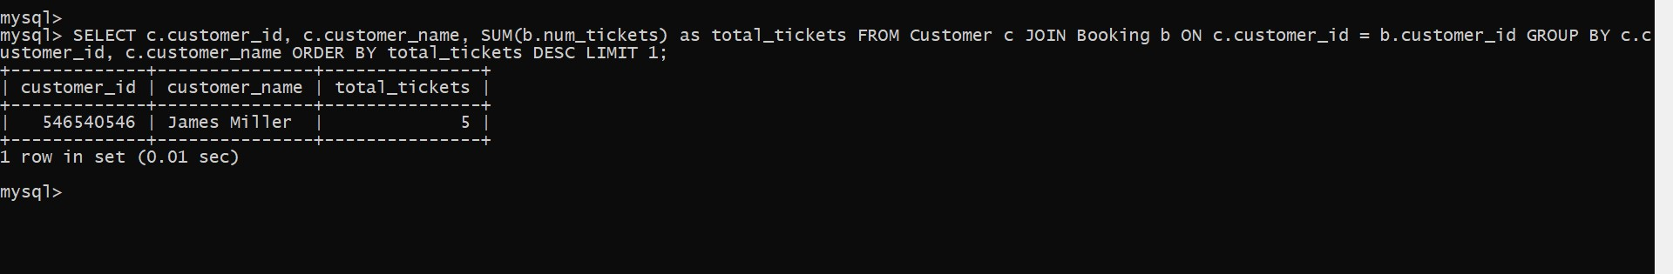

1. Write a SQL query to List Events and the total number of tickets sold for each month.

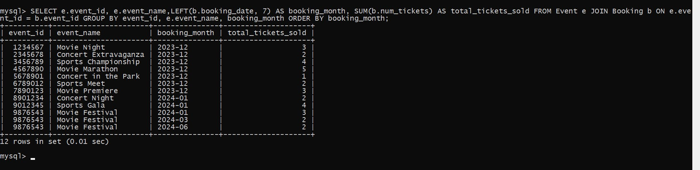

1. Write a SQL query to calculate the average Ticket Price for Events in Each Venue.

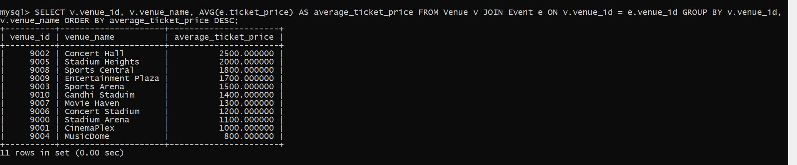

1. Write a SQL query to calculate the total Number of Tickets Sold for Each Event Type.

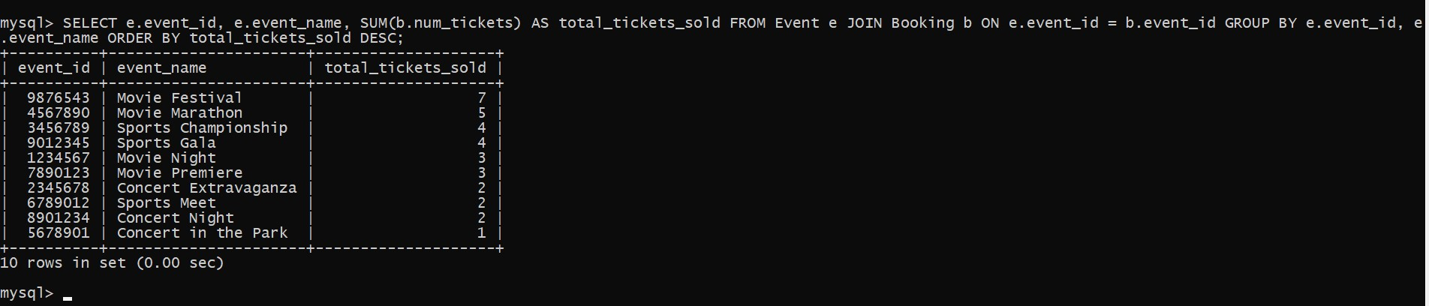

1. Write a SQL query to calculate the total Revenue Generated by Events in Each Year.

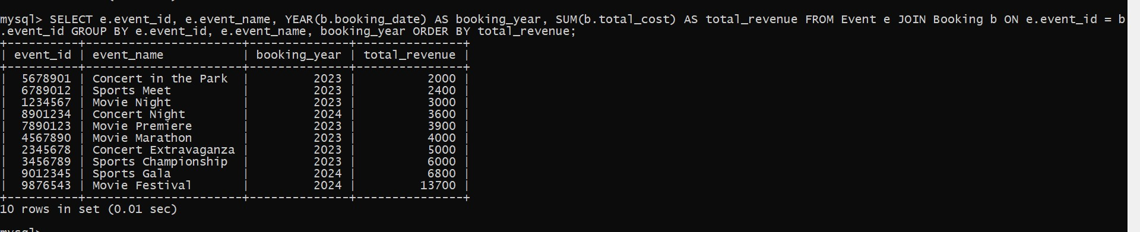

1. Write a SQL query to list users who have booked tickets for multiple events.

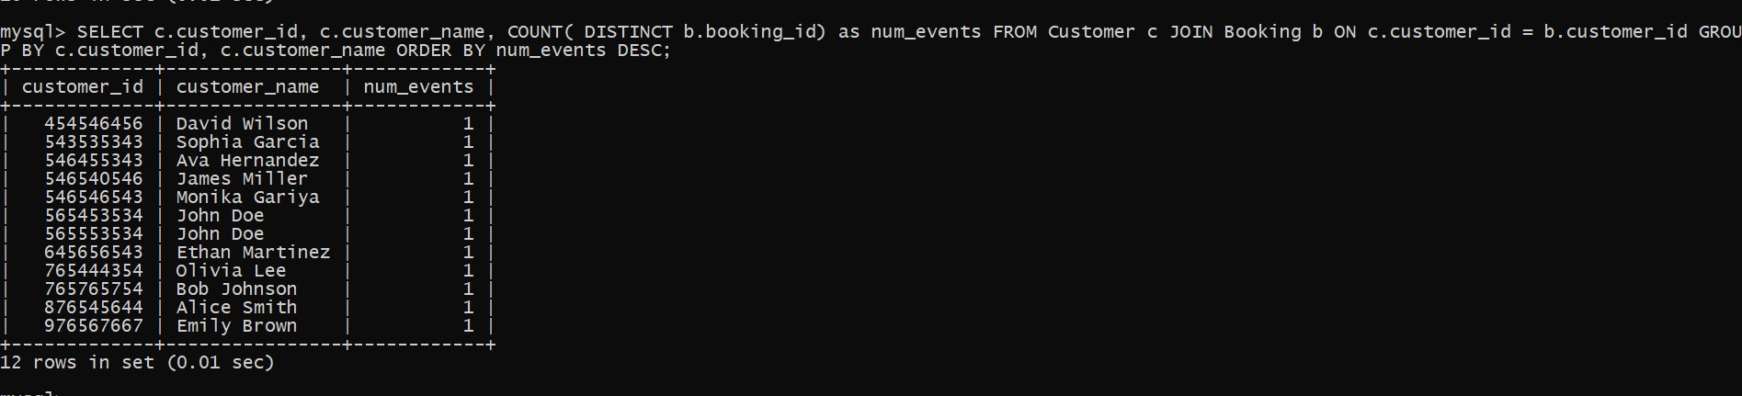

1. Write a SQL query to calculate the Total Revenue Generated by Events for Each User.

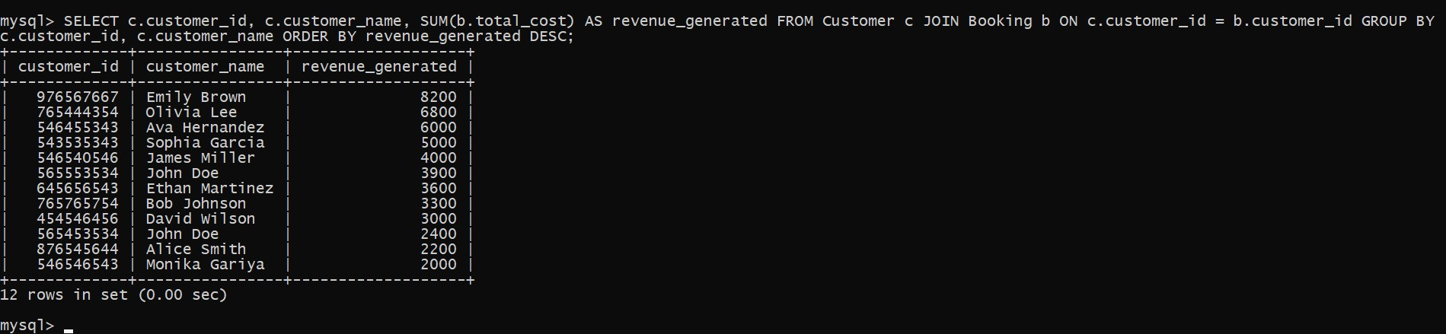

1. Write a SQL query to calculate the Average Ticket Price for Events in Each Category and Venue.

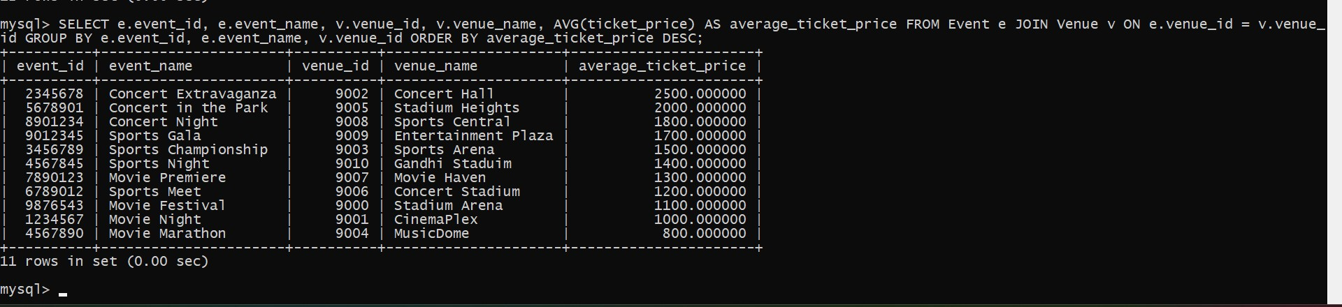

1. Write a SQL query to list Users and the Total Number of Tickets They've Purchased in the Last 30 Days.

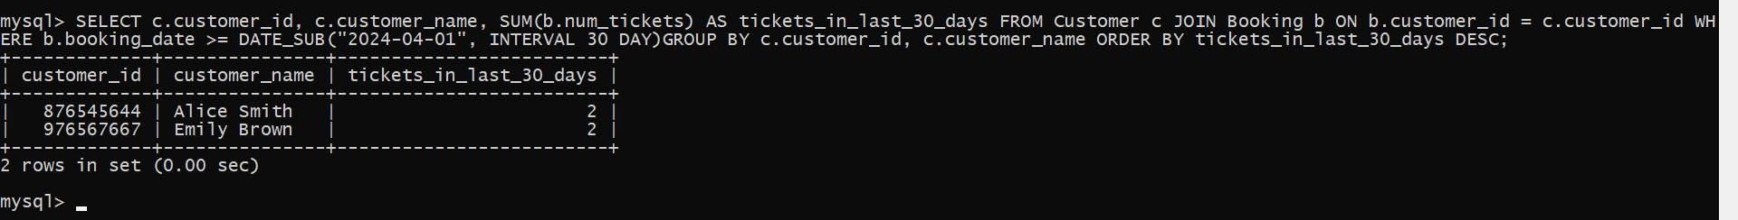

**SUBQUEREY**

1. Calculate the Average Ticket Price for Events in Each Venue Using a Subquery.

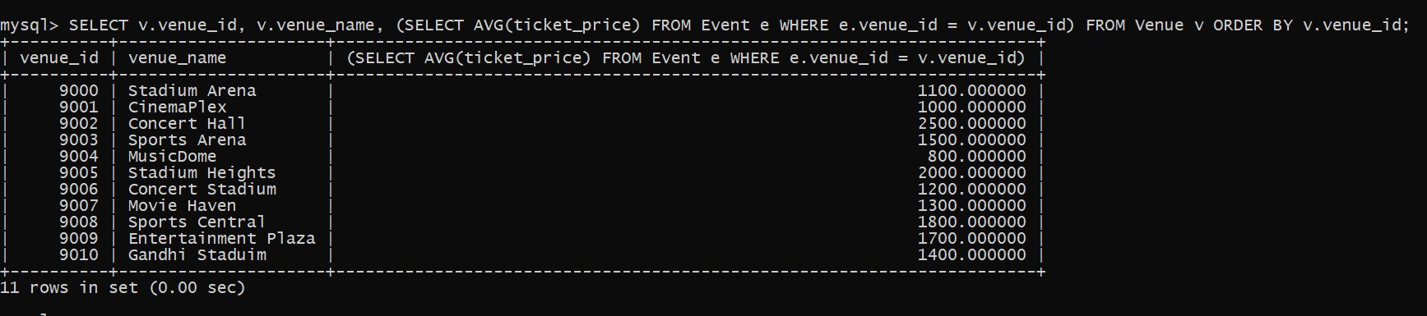

1. Find Events with More Than 50% of Tickets Sold using subquery

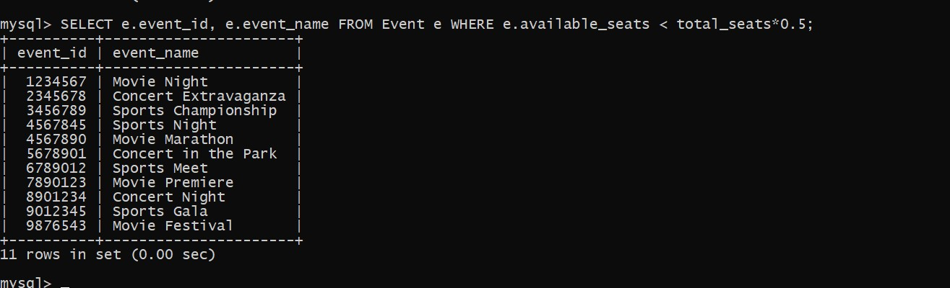

1. Calculate the Total Number of Tickets Sold for Each Event.

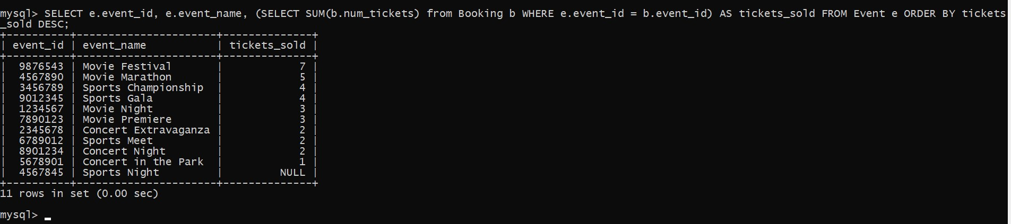

1. Find Users Who Have Not Booked Any Tickets Using a NOT EXISTS Subquery

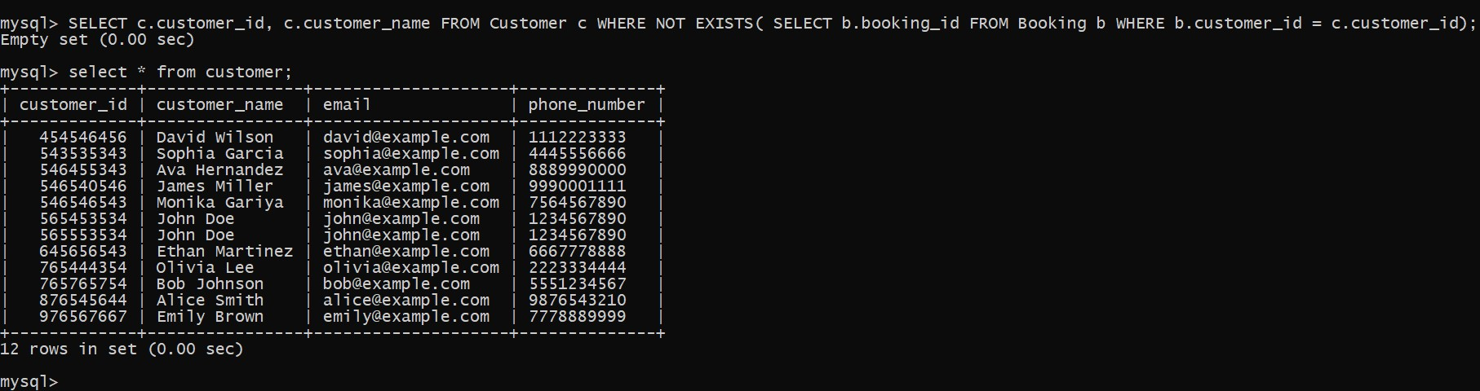

1. List Events with No Ticket Sales Using a NOT IN Subquery.

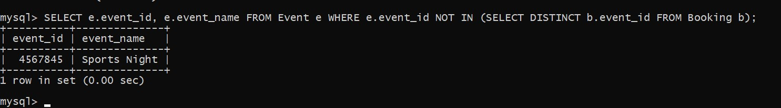

1. Calculate the Total Number of Tickets Sold for Each Event Type Using a Subquery in the FROM Clause.

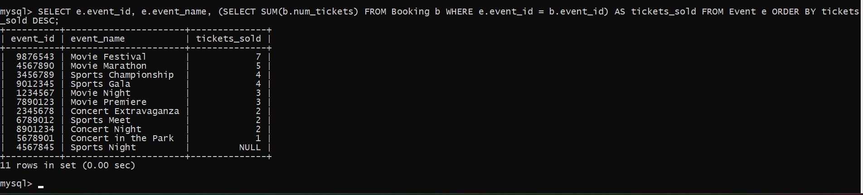

1. Find Events with Ticket Prices Higher Than the Average Ticket Price Using a Subquery in th e WHERE Clause

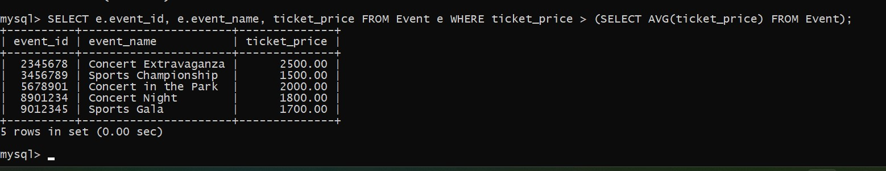

1. Calculate the Total Revenue Generated by Events for Each User Using a Correlated Subquery.

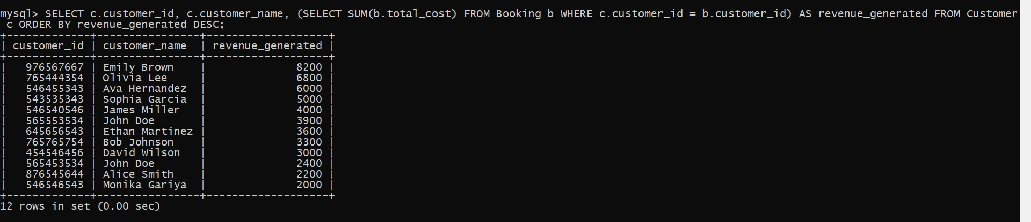

1. List Users Who Have Booked Tickets for Events in a Given Venue Using a Subquery in the WHERE Clause.

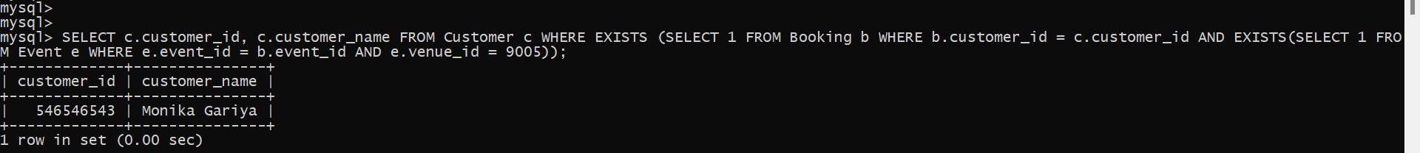

10.Calculate the Total Number of Tickets Sold for Each Event Category Using a Subquery with GROUP BY

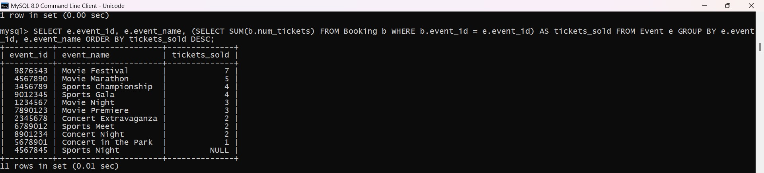

11.Find Users Who Have Booked Tickets for Events in a Given Month Using a Subquery with DATE_FORMAT



12. Calculate the Average Ticket Price for Events in Each Venue Using a Subquery

